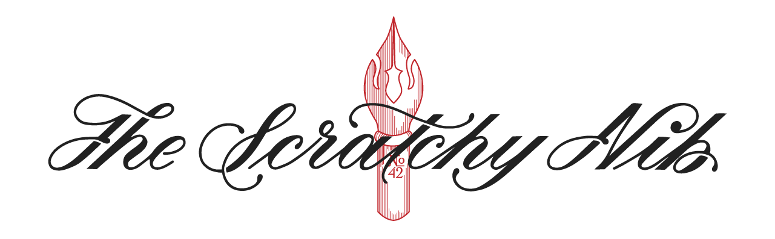



APTECH LEARNING PAKISTAN

Aptech Metro Star Gate Center

Karachi



**Scratchy NIB**

Calligraphy Website

# E-PROJECT

# 

|  |  |  |
| --- | --- | --- |
| Faculty | SIR MUSTAJAB MUSTAFA | |
| Batch | PR2-2023-06F TTS | |
| Serial NO. | **Enrollment NO** | **Student Name** |
| 1 | Student | Feroz Naeem |
| 2 | Student | Bint e Zahra |
| 3 | Student | komal |

Catalog

SCRATCHY NIB------------------------------------------------------------------------------------(1)

GROUP-MEMBERS--------------------------------------------------------------------------------(3)

CERTIFICATE OF COMPLETION----------------------------------------------------------------(3)

ON ---------------------------------------------------------------------------­­­­­­­­------------------------(3)

JANAUARY 16TH ,2024----------------------------------------------------------------------------(3)

USERS’S GUIDE-------------------------------------------------------------------------------------(7)

(2) WORKSHOPS-----------------------------------------------------------------------------------(3)

(3) ABOUT-----------------------------------------------------------------------------------------(1)

(4) LESSONS AND UPDATES-------------------------------------------------------------------- (1)

(5) FOOTER-----------------------------------------------------------------------------------------(1)

CERTIFICATE OF COMPLETION

This is to certify that **FEROZ NAEEM , BINT EZAHRA**

**& KOMAL**have successfully completed their **HDSE**\*

Semester 1 E-Project.

Submitted to: **APTECH COMPUTER EDUCATION**

**ON**

**Aug 16th -2024**

**ACKNOWLEDGEMENT**



**First of all, we would like to thank Almighty Allah for giving us strength and**

**ability to complete this project.**

**And then, we would like to express my special thanks of gratitude to our teacher Sir MUSTAJAB MUSTAFA who guided us on the**

**Project * Scratchy NIB * which also helped us in doing a lot of new learning and we come to know about so many new things we are really thankful to him.**

**We are highly thankful to Sir MUSTAJAB MUSTAFA for his guidance and constant supervision as well as for his support in completing the project.**

**Lastly, we would also like to thank our parents and friends who helped us a lot in finalizing this project within the limited time frame. We also express**

**our sincere gratitude to E-Project team from Aptech Head Office, for their valuable guidance and support for the completion of this project. We earnestly hope this project will provide all the necessary information**

**required by the user to full fill his/her inspiration. However, suggestion and Feedbacks for improvements will be thankfully welcomed &acknowledge.**



The thirst for learning, upgrading technical skills and applying the concepts in real life environment at a fast pace is what the industry demands from IT professionals today. However busy work schedules, far-flung locations, unavailability of convenient time-slots pose as major barriers when it comes to applying the concepts into realism. And hence the need to look out for alternative means of implementation in the form of laddered approach.

The above truly pose as constraints especially for our students too! With their busy schedules, it is indeed difficult for our students to keep up with the genuine and constant need for integrated application which can be seen live especially so in the field of IT education where technology can change on the spur of a moment. *Well, technology does come to our rescue at such times!!*

Keeping the above in mind and in tune with our constant endeavour to use Technology in our training model, we at Aptech have thought of revolutionizing the way our students learn and implement the concepts using tools themselves by providing a *live and synchronous eProject learning environment!*



There are so many aspects of creating art that are fun an enjoyable – the practice, experimentation, and work to make each piece – that hours pass as if they were minutes. Sharing and engaging with the amazing writing community to help other create their own masterpieces is also incredibly rewarding.

Calligraphy has become very popular recently – examples of it can be seen in many advertising areas, restaurant menus, posters and even party invitations. It’s very loosely based on Copperplate calligraphy, which is a lot stricter in form and design.

Scratchy Nib is one place, which brings together the art of Calligraphy along with the knowledge and history.

You are supposed to create a Single-Page-Application and responsive Website for them with the below mentioned requirement specifications.

The website is to be developed for the Windows Platform using HTML5, JSON, Angular JS, JavaScript and Geolocation. The site should work well in all leading browsers including Chrome, IE, Firefox etc.



The portal will be designed as a Single-Page-Application and responsive Website with a set of pages and menus that represent choice of activities to be performed. The pages, menus, and other visual elements must be designed in a visually appealing manner with attractive fonts, colors, and animations.

All of these should also be laid out in a responsive manner

The Web site is to be created based on the following requirements.

1. Top of the website should have Title in Calligraphic and should provide brief information about calligraphy as from where it originated etc.
2. There should be a well-designed menu with all sections listed.
3. Various sections such as Traditional Calligraphy, Contemporary Calligraphy, Hand-lettering & Design, Modern Calligraphy etc. should be provided.
4. Section explaining various forms and styles should be provided.
5. Filter on designs as Arabic, Indic, Greek etc should be provided.
6. Proper description of the letters and fonts must be added in the website.
7. Gallery should be added for viewing different Calligraphic styles.
8. Feedback must be allowed to enter by the viewer
9. Site map, Gallery, about us, Queries link, Contact us link must be added.
10. About Us and Contact Us: This menu option should display Email id, address, and contact number of the organization4.
11. Color combination must be uniform throughout the project.
12. Navigation must be smooth.

Over and above this, the portal should implement the following functionalities:

* Display a continuous scrolling ticker at the bottom of the page with current date, time, and location (hint: Use geolocation features of HTML5).
* Display a visitor count at the top right corner of the page beside a logo image.
* The menu options should change color on hover and also after clicking.
* Fade in and fade out options can be used for the menus.



**Hardware**

* Intel Core i3/i5 Processor or higher
* 8 GB RAM or above
* Color SVGA
* 500 GB Hard Disk space
* Mouse
* Keyboard

**Software**

Technologies to be used:

* Frontend: HTML5, CSS, Bootstrap, JavaScript, jQuery, AngularJS, XML
* Data Store: JSON files or TXT files

Other Requirements:

* Operating Portal: Windows
* Browsers: Edge, Chrome, Mozilla Firefox, Safari

**USER’S GUIDE**

HOME PAGE

Prototype (Screen Shot of the Project Interface)

1. **Home Page:**

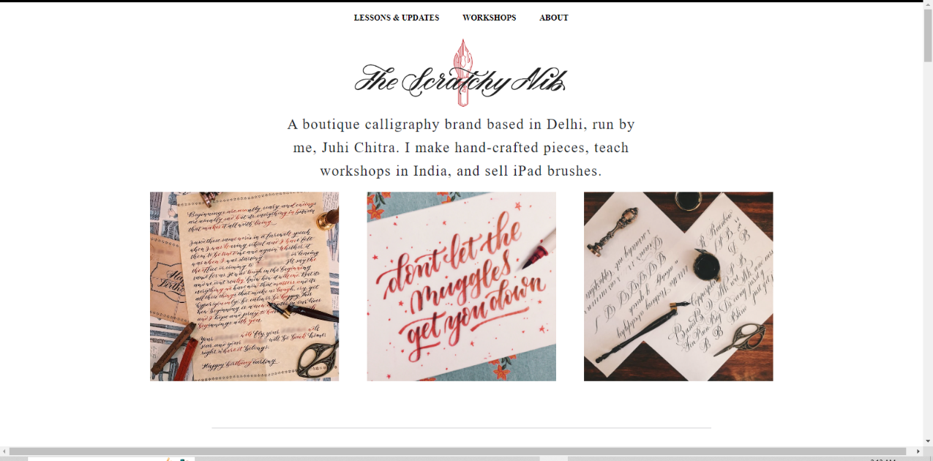

1. **About**

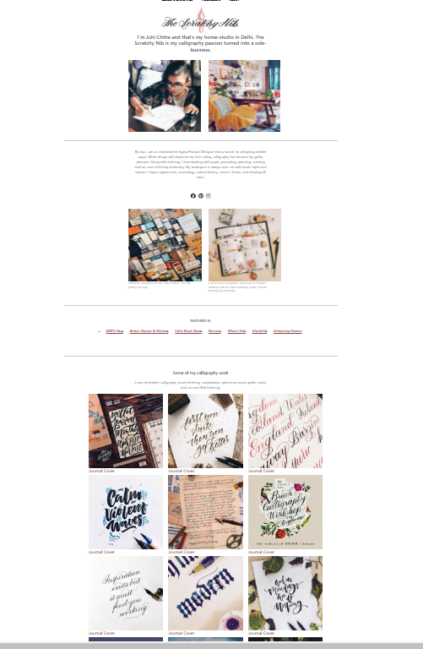

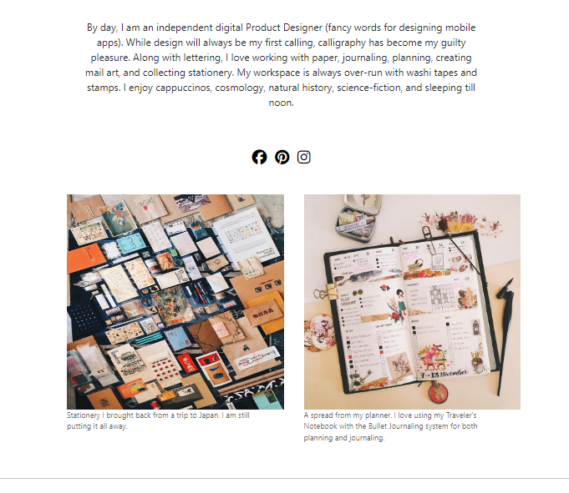

1. **LESSONS AND UPDATES**

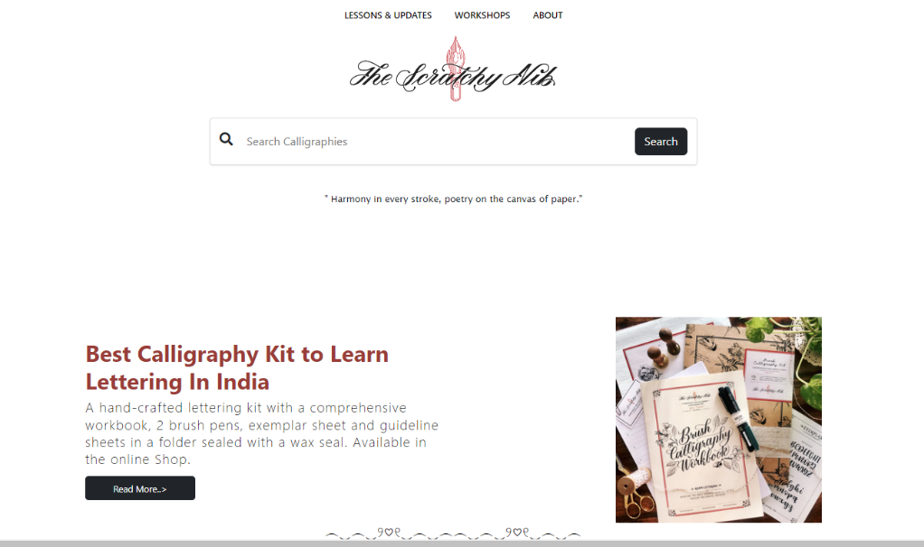

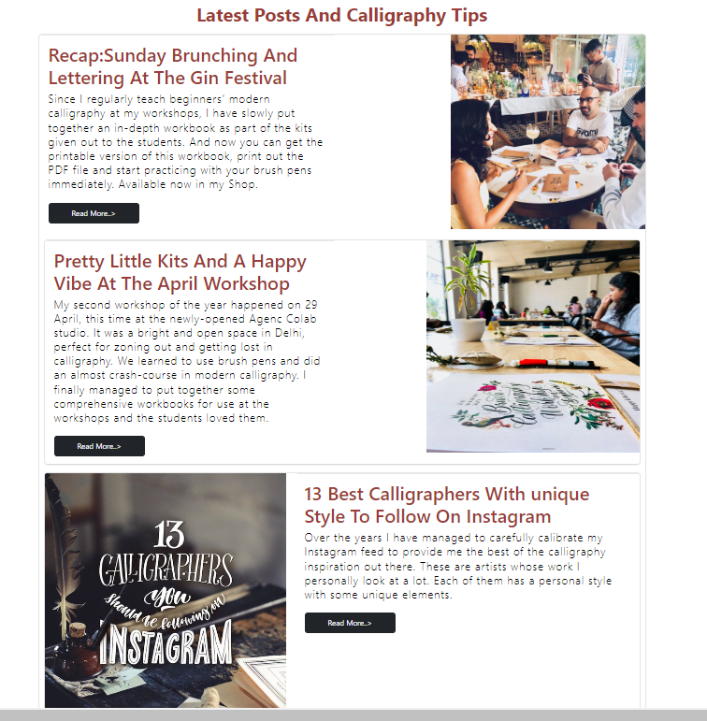

**FOOTER**

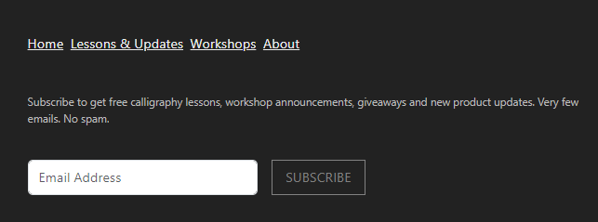

**Signature: _____________**